CALLOUT FOR SEE IT FIRST PROGRAMME PERFORMANCE SLOTS
The Belgrade Theatre is thrilled to open applications for Midlands-based creatives to perform new work as part of See It First 2025, an exciting programme of new work, workshops, and conversations between artists and audiences. This opportunity marks the inaugural performances in our brand-new Jag performance and rehearsal space – a bold new chapter for the theatre ecology in Coventry.

We are offering
- A paid opportunity to preview work ahead of touring or other performance opportunities in one of the Midlands’ top producing theatres

- Access to support from the Belgrade Theatre team prior to & during your time with us. This includes:
  - The opportunity to take pictures & video of work and test work in front of an audience
  - Being part of See It First, a programme of new work, workshops and conversations between artists and audiences. More info here: https://www.belgrade.co.uk/events/see-it-first-2025/
  - Being part of the inaugural performances in our new Jag performance space

Fee
The Belgrade Theatre will pay Visiting Companies a fee ranging from £300-£1000. This will be dependent on several factors including company/cast size and the stage of development the work is currently at.

Performance Slots
- Space: The Jag Basement (see images on the webpage)

- Dates: One evening performance on one of the following days: Weds 23, Thu 24, Fri 25 and Sat 26 Jul 2025

- Proposed schedule:
  - Space Familiarisation: 9 AM-12 PM
  - Tech Rehearsal: 1 PM -6 PM
  - Evening Performance (show time tbc)
This is a suggested schedule and to be discussed with the needs of the chosen show.

Technical
We will provide one multi-skilled technician to support with any technical aspects depending on requirements throughout your time with us.
The Jag Basement Specifications:
- Stage Space: 6m x 4m

- Thrust configuration (seats in front and on stage left) - Capacity up to 46 Alternatively, End-On configuration, capacity up to 30

- Height 2.4m. Please be aware larger set elements may struggle to access the space due to nature of underground space

- A floor plan can be found at the bottom of this document

- We are equipped with basic theatre audio and lighting equipment

- Please note there are no flying/hanging capabilities and that it is difficult to bring theatre flats into the space as the get-in is through a single door and staircase.

Marketing
From a marketing perspective, we will work with you on promoting your show during your time here. Your show will be a part of our See It First Season, a programme which brings the best work to Coventry to be shared with local audiences before anyone else.
The Belgrade Communications Team will provide the following support:
- Your show/event listed on the Belgrade Theatre website

- Inclusion in See It First print

- Inclusion in See It First press release

- Inclusion in local online listings

- Organic social media support across Facebook, Instagram, X, Tik Tok and where appropriate, LinkedIn

- Inclusion in See It First sponsored Meta posts

- Inclusion in See It First sponsored Google Display Network sponsored adverts

- Inclusion in composite See It First e-shots to the database and 1 x solus e-shot to target audiences

Tickets
Tickets will be sold through our Box Office for £5. A small number of complimentary tickets will be offered to the company for invited guests.

What We’re Looking For
- Work made by Midlands-based creatives, ideally with a connection to Coventry and the local area

- New productions (i.e. never been seen in a full production by a public audience)

- Shows that are ready to meet a public audience, at any stage of their development.

We expect creatives applying to:
- Have already secured funding or be in the process of acquiring funding to support the development of the production

- Have already or be able to independently assemble a creative team, cast actors, and hold rehearsals.

- Provide us with copy and images for on sale

- Be going on to further opportunities (e.g. festival or tour) or planning for this in the future

How to Apply
You can apply via our application form. For longer responses, there is the option to upload a video or audio response rather than written text. You will also have the opportunity to upload supporting files like a script or video.
Please fill in the form here.
If you have any access needs that require alternative formats, or have any questions, please email communityadmin@belgrade.co.uk
We’re happy to chat further if you want to know more about this opportunity and if it’s right for you.
The deadline for applications is Sunday 4 May 2025
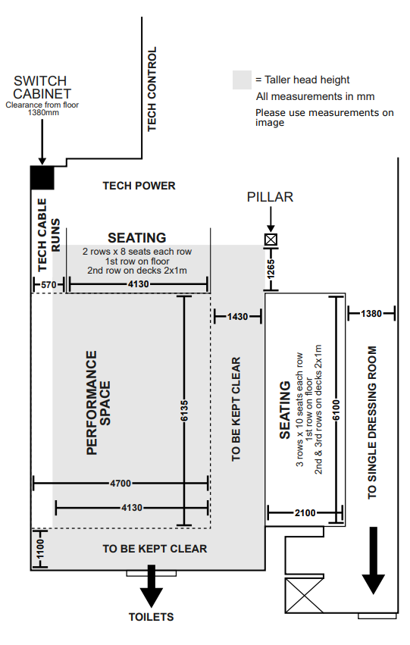
We will aim to offer artists a slot by Thursday 8 May.

